BLIS – Kenya

Technologists Guide

Rev 2.0

A joint initiative of C4G @ Georgia Tech, the CDC, @iLabAfrica – Strathmore University , Association of Public Health Laboratories (APHL) and participating countries

2015



Table of Contents

**1.0** **Getting started with BLIS** 1

**1.1** **Signing into BLIS** 1

**2.0** **Patient listing and registration** 3

**2.1** **Listing patients** 3

**2.2** **Registering a patient** 3

**2.3** **Viewing a patient’s details** 4

**2.4** **Editing a patient’s details** 4

**3.0** **Laboratory tests** 6

**3.1** **Listing ordered tests** 6

**3.2** **Searching for a lab request** 6

**3.3** **Booking a test** 6

**3.4** **Viewing a lab test request** 9

**3.5** **Accepting a specimen** 10

**3.6** **Rejecting a specimen** 10

**3.7** **Referring a Test** 11

**3.8** **Starting a Test** 12

**3.9** **Entering test results** 13

**3.10** **Full Haemogram results on Celltac F machine** 13

**3.11** **Editing Test Results** 15

**3.12** **Verifying test results** 15

**4.0** **Reports** 17

**4.1** **Daily Reports** 17

4.1.1 Patient report 17

4.1.2 Daily log 18

**4.2** **Aggregate reports** 20

4.2.1 Prevalence Rates 20

4.2.2 Counts reports 22

4.2.3 Turnaround time report 24

4.2.4 Infection report 25

**5.0** **User Account** 26

**5.1** **Editing your user profile** 26

**5.2** **Changing your password** 26

**5.3** **Signing out of the BLIS** 27

**Glossary** 28

# **1.0 Getting started with BLIS**

To start the Basic Laboratory Information System, you must click on the bookmark saved on the web browser e.g. Google Chrome or Mozilla Firefox. You will then see a page requesting login information. You must then enter your credentials to proceed.

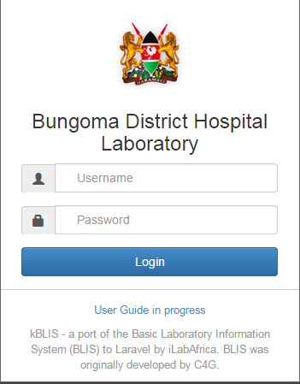

## **1.1 Signing into BLIS**

1. Fill in your username and password then click  
2. If you try to sign in while either of the username or password fields is blank, you will get errors as displayed below 
3. If you try to sign in with unmatching username or password, the following errors shall be displayed. 

If you have forgotten your password, kindly contact the lab-in-charge for help.

On successful sign-in, you should see such a page as this.

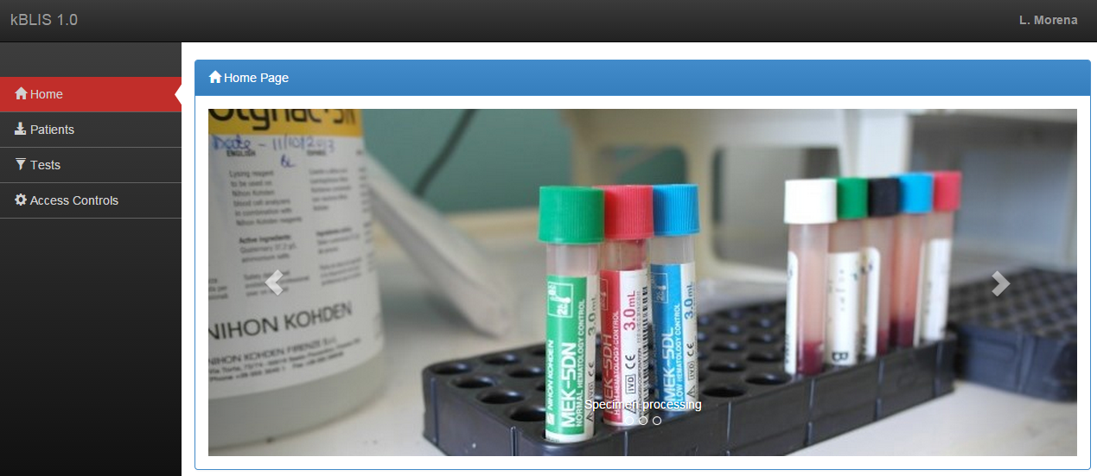

# **2.0 Patient listing and registration**

This section allows for patient registration in the case of referred patients or those not registered in the hospital EMR system. A listing of all the patients available is shown as captured below.

## **2.1 Listing patients**

1. From the homepage, click tab on the navigation menu for the patients list portlet to be shown

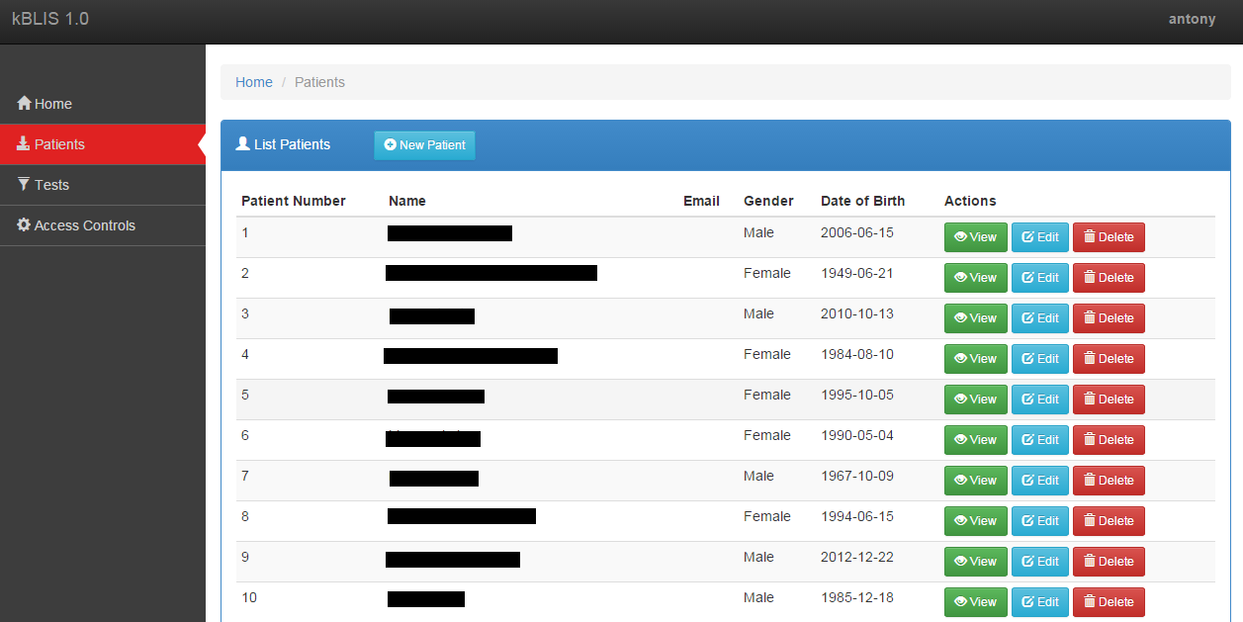

## **2.2 Registering a patient**

1. To register a patient, click on the  button at the top of the blue portlet.
2. After completing the form, click the button at the bottom of the form. Using the **Save** button will instantly save the details to the system.

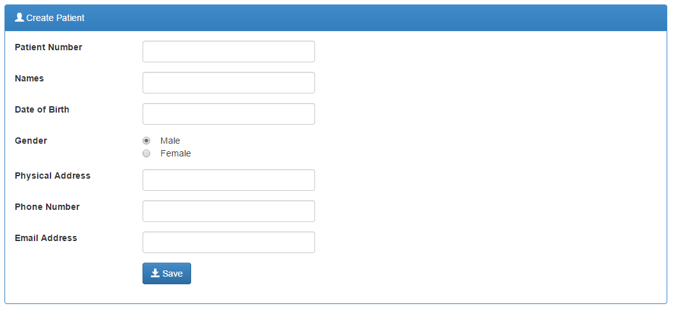

## **2.3 Viewing a patient’s details**

1. To see details of a particular patient, click the view button button on the **Actions** column with the corresponding row of the patient listed to see the details as shown below.

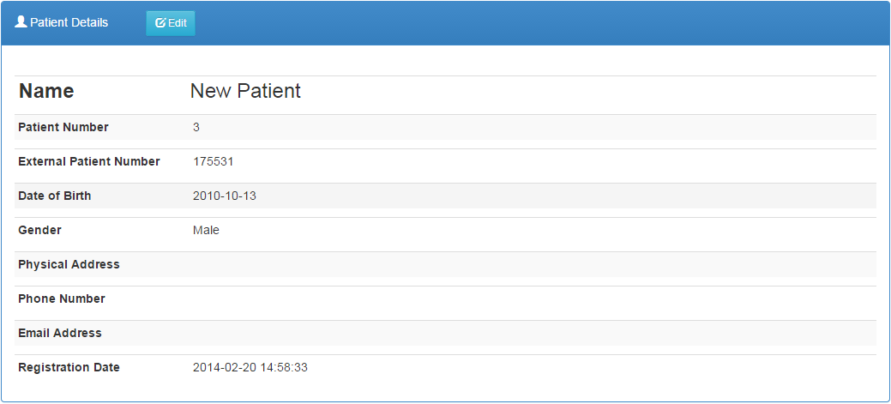

1. To get back to the patients list, click on **Patients** hyperlink on the breadcrumb.



## **2.4 Editing a patient’s details**

1. On the patients list, click on the Edit resultsbutton
2. After making your modifications, click the button to push the changes to the system.
3. An alternative way to edit patient details is to use the view button button on the patients list then click on the Edit resultsbutton once the details have been displayed.

# **3.0 Laboratory tests**

Different medical systems have distinct stages and processes of conducting medical test. This document will track the life cycle of a medical test on-board iBLIS.

After receiving test request from a patient or other embedded systems the immediate step is to book for the test via the laboratory system. The initial stage of capturing the test details is most important stage. In essence, accurate data capturing will streamline the logical steps to ensure that what you test is what you meant to test, and that the final test report meets the client’s needs and expectations.

## **3.1 Listing ordered tests**

1. Click the  tab on the navigation menu to load a list of all ordered tests.

## **3.2 Searching for a lab request**

Below is the first interface during the testing process.

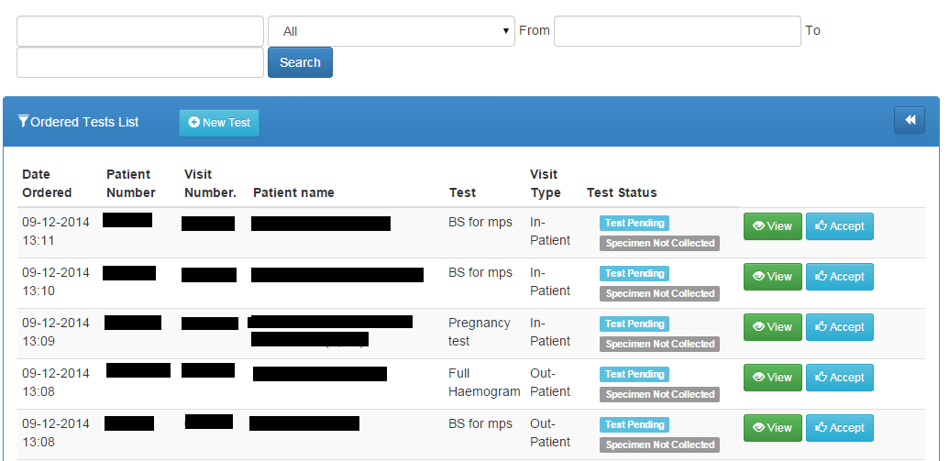

1. There are several search fields on UI. The first one allow you to filter the test based on the test type, patient number, name, visit number and type, the second one will allow you to filter using test status and third one will use date as the filtering criteria.
2. Once you have your search parameters in place, click the  button

## **3.3 Booking a test**

For referrals to the lab and tests that do not originate from the hospital EMR system, lab requests have to be created at the lab.

The iBLIS system can accept and initiate test requests through different approaches.

###### i). By use of the Tests Link

The step below shows how ordering a test from the default tests page can be achieved.

1. Click the button to launch the test order form.
2. Select the desired patient by tying the patient Id or Name or by clicking the GO button to list the available patients.

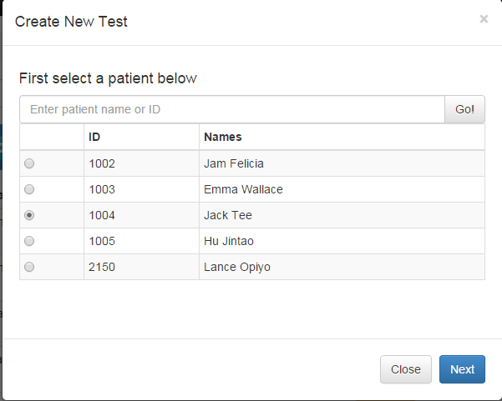

1. Click the button to launch the new test order form.
2. In the New test page, input the visit type, the requesting physician and from the listed tests, select the desired test(s).

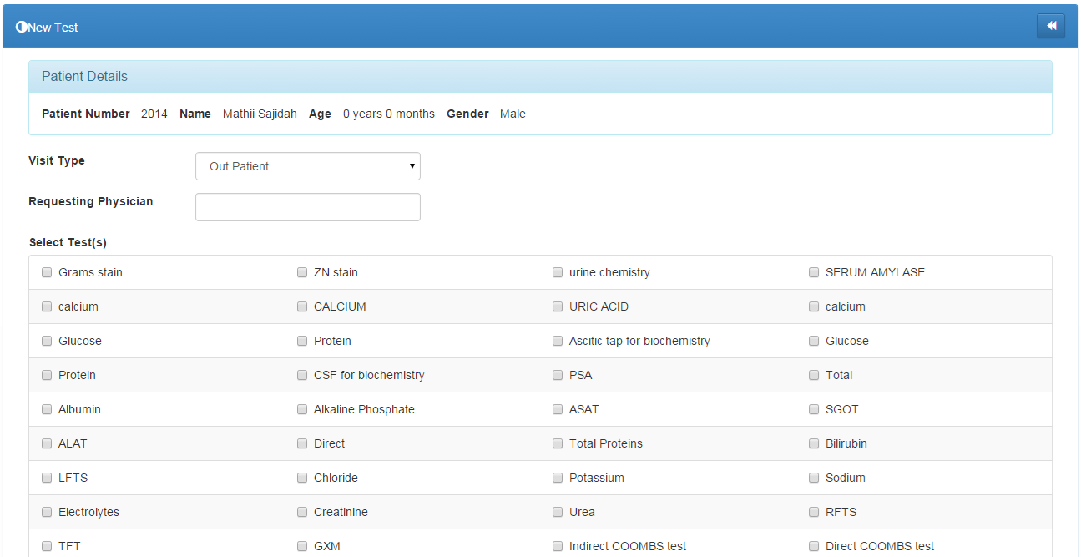

1. Click the button to save the details.

###### ii). By use of the patient's details page

A test can be booked directly from the patient details page. This page can be accessed after selecting the patient at subject of the tests.

1. Click on the  link on the side bar navigation menu on the left of the screen.
2. Identify the desired patient and click the corresponding view button button to load the Patient Details page.

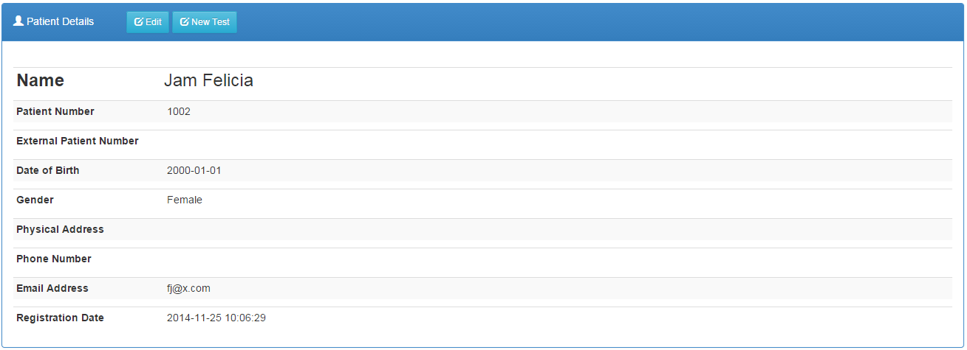

1. Click the  button.

###### iii). By use of an external system

A test can also be booked via an external system. BLIS will have a module through which a test order can be invoked by multiple external systems. This will only happen if the systems can integrate and map fully with BLIS. External system configuration and integration with BLIS will depend on the available systems in any given hospital. All the embedded systems will fully be tested to ensure a smooth running of BLIS and the particular system at stake before inter-dependability can be authorized.

## **3.4 Viewing a lab test request**

1. On the ordered list of tests, click on the view button button on the corresponding row of the request.

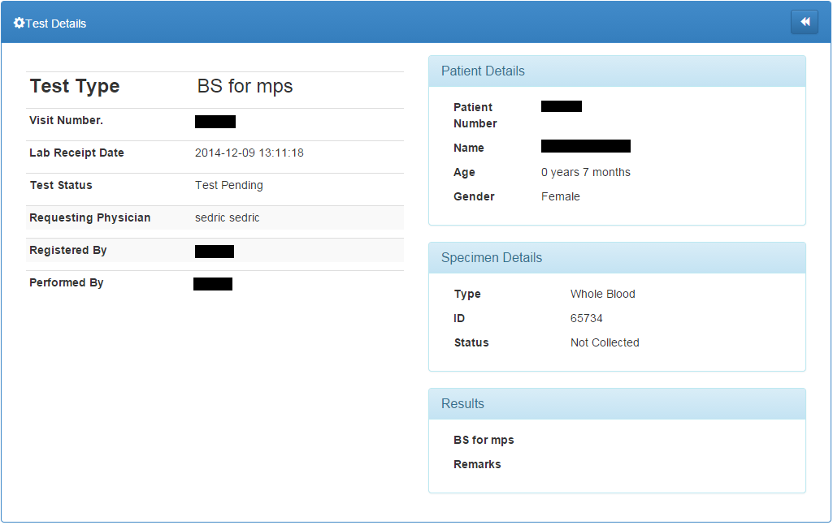

1. To get back to the test list, click the  icon on the top right corner of the ‘Test Details’ portlet.

## **3.5 Accepting a specimen**

Before the testing process is started the acceptance of the specimen must be registered in the iBLIS system. This will be achieved through;

1. Click on the  link on the side bar navigation menu on the left of the screen.
2. Select the test of interest and check where Test Status is 
3. Click on the Accept button button to acknowledge the specimen.
4. This will change the specimen status to  and the button to the test will show plus a  button in case the specimen is deemed unsuitable.



## **3.6 Rejecting a specimen**

Specimen can be rejected on several levels in iBLIS. The first level is during specimen collection. Mistakes can be made hence making the specimen unsuitable. On other occasions the specimen samples can be damaged or contaminated during testing. If the collected specimen cannot progress to testing and actualize the test due to various reasons it can then be rejected through;

1. Click on the  link on the side bar navigation menu on the left of the screen.
2. Select the test of interest and check where Test Status is 
3. Click on the Reject button button to reject the specimen.
4. Fill in the form appropriately then click the Reject button button at the bottom to complete the rejection.

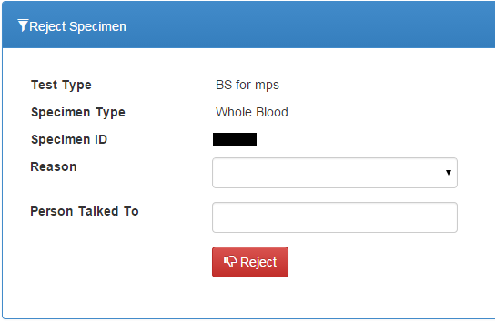

1. You will be notified of any errors during rejection like 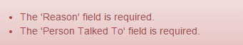

Or successful rejection 

## **3.7 Referring a Test**

In some cases the hospital may not have the capability to actualize some of tests.This will result to the test being referred to another medical institution for testing. The accepted specimen can be referred via;

1. Click on the  link on the side bar navigation menu on the left of the screen.
2. Select the test of interest and check where Test Status is  and .
3. Click on the Refer Sample button button.
4. Fill in the form

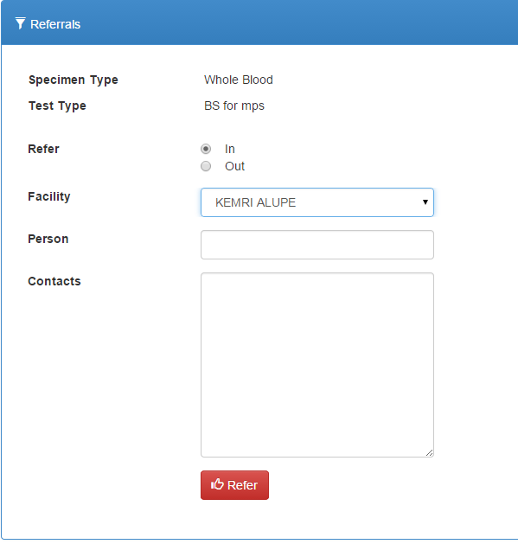

1. Click the  button

NB: The process is similar for both referred-in tests and those referred out. You just have to indicate whether it is a refer In or out 

## **3.8 Starting a Test**

A test can only be started if the collected specimen is suitable. Once the specimen is verified and allowed to proceed to testing;

1. Click on the  link.
2. Select the test of interest and check where Test Status is  and .
3. Click on the Start button button to commence the testing process. The test status changes to 

## **3.9 Entering test results**

After a successful test, the results are then recorded into iBLIS. The page can be accessed via;

1. Click on the  link.
2. Select the test that whose results are ready.
3. Click on the Enter results button button to feed the results into the system.
4. Fill in the results form e.g. 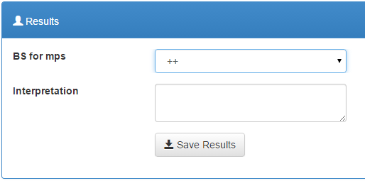
5. Click the  button to save the results to the system

## **3.10 Full Haemogram results on Celltac F machine**

1. Click the Enter results button button on the corresponding test on the list of tests.
2. On the Celltac F machine; press Print Results button to send the results from the Celltac F machine to the computer.
3. Click the  button on the results panel to autofill the form with the test results as shown below.

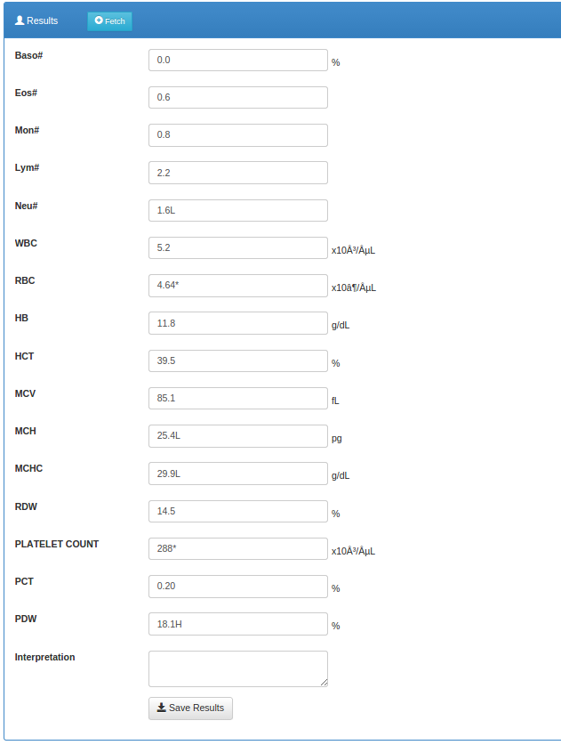

1. Click the  button to save the results to the system

## **3.11 Editing Test Results**

If the test results were entered incorrectly they can be edited. This can only be done before test verification. Follow the steps below to edit test results;

1. Click on the  link.
2. Select the test whose results are to be edited and test status is .
3. Click on the Edit results button to make the changes.
4. Make the necessary modifications on the form presented such as 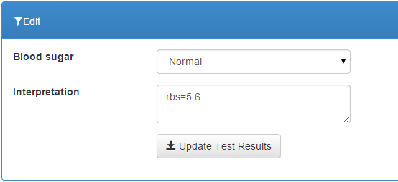
5. Click the button to save the changes.

## **3.12 Verifying test results**

A test can only be verified if all the above processes and conditions are correctly actualized. The verification will be done by an experienced medical personnel. The results will be compared against preset criteria designed for verifying the particular test;

1. Click on the  link.
2. Select the test whose results are to be verified and test status is .
3. Click on the button button to proceed to the test details page. 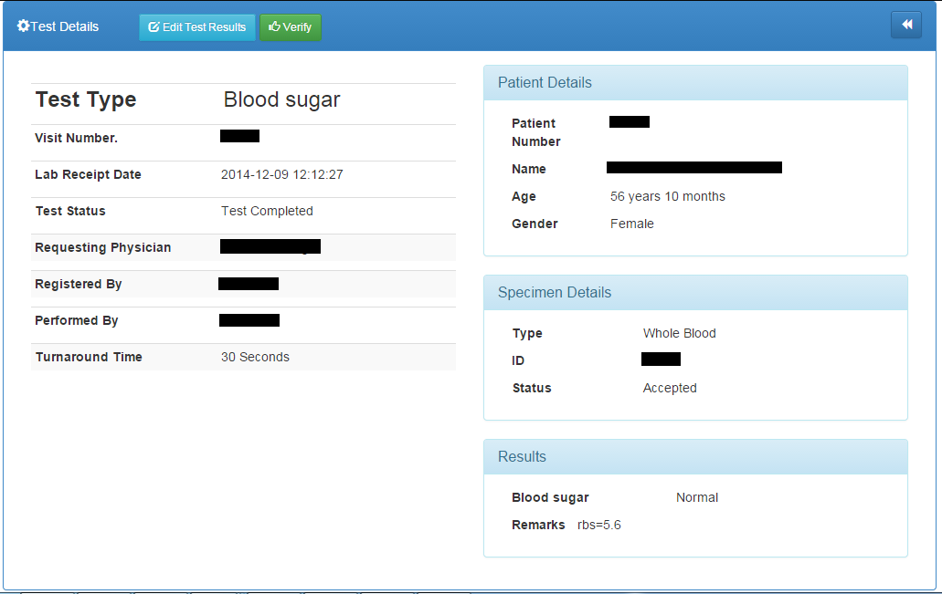
4. Click on the button button on the test details page to commit the verification.

# **4.0 Reports**

1. Click on the  link to open the reports module.

## **4.1 Daily Reports**

The Patient Report and Daily Log should be run every day.

### 4.1.1 Patient report

1. Click the  link on the Reports sub-menu to open the patients reports listing

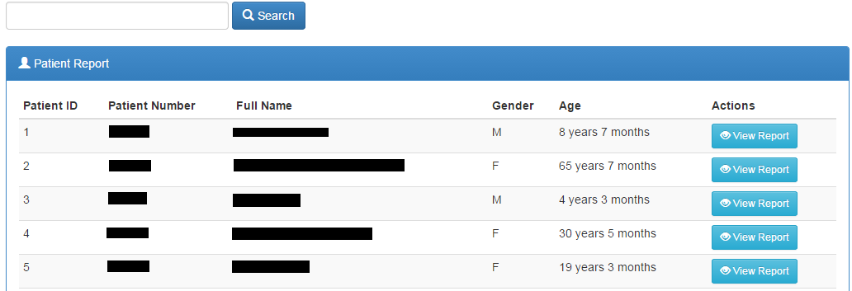

1. Search for the patient by Patient Name, Patient Number, or Patient ID.
2. Click the  button to start search.
3. Select the patient you want from the list if more than one patient matches your search criteria.
4. Click  to see all data for that patient.

You can edit the report to show activity within a date range, include pending tests for which results are not available, set printing information, or export to Word using the controls at the top of the page.

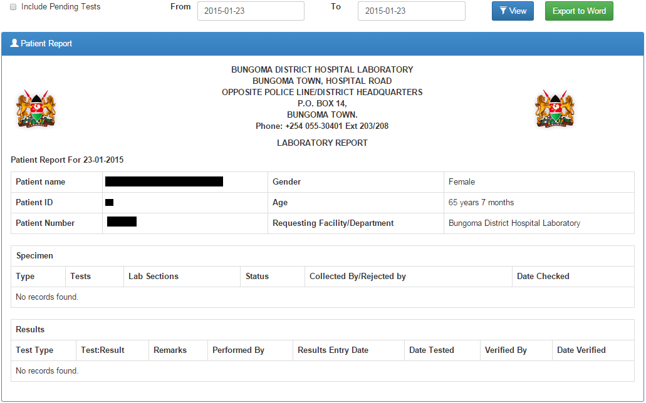

1. Click  to filter the report and  to export to word document.

### 4.1.2 Daily log

1. Click the  sub-menu under reports to view daily logs.
2. Set the date range to reflect the log to print. You can run a report of the day’s activity by patients seen (by clicking Patient Records), or by tests run (by clicking Test Records) or rejected specimens (by clicking Rejected Specimen Records).

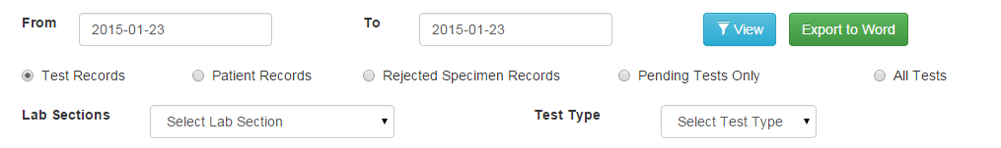

#### 4.1.2.1 Test Records

You can choose to run a log for one lab section or for one type of test, for all tests or pending tests only. The default settings are test records, all sections, and all tests. The report loads with Export controls at the top of the page.

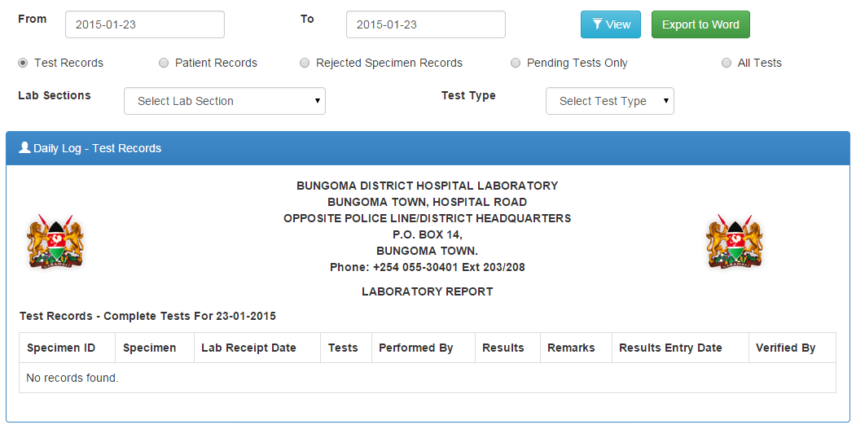

#### 4.1.2.2 Patient records

1. Click on the  checkbox
2. Apply the filter parameters, date ranges in this case
3. Click the  button to load the report
4. Click the  button to toggle the summary

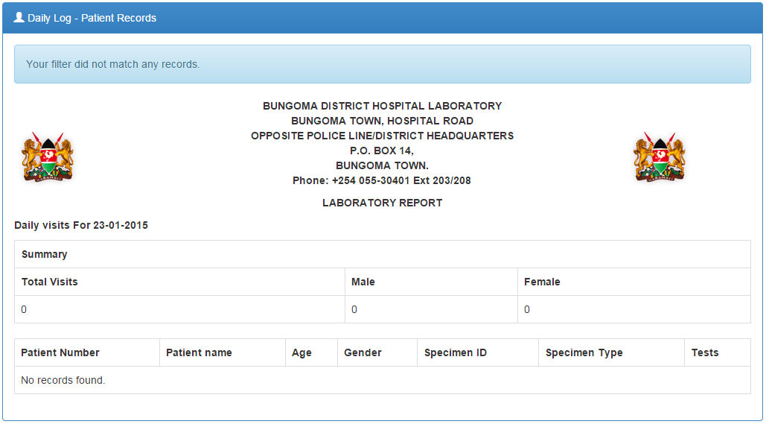

1. Click the  button to export the report to word document for further processing

#### 4.1.2.3 Rejected Specimen records

1. Click the checkbox then  button to load the report

You can choose to run a log for one lab section or for one type of test. The default settings are test records, all sections, and all tests. The report loads with Export controls at the top of the page

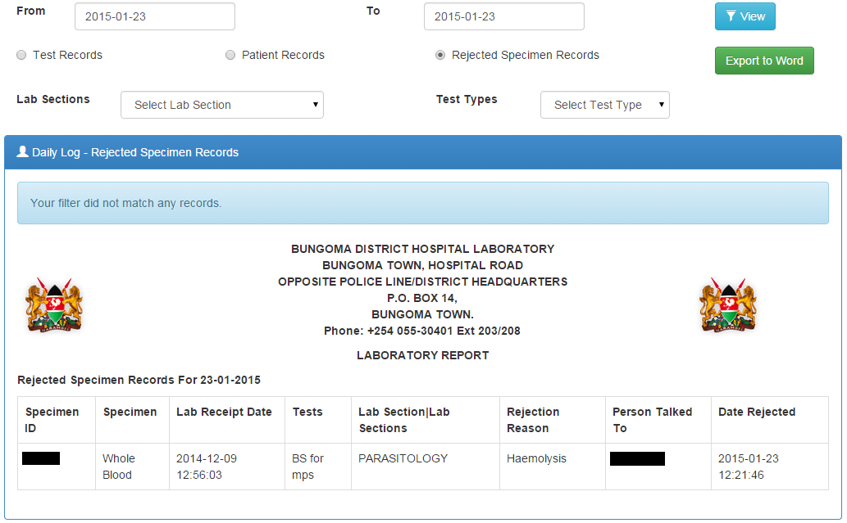

## **4.2 Aggregate reports**

These are accrued summaries over a period of time.

### 4.2.1 Prevalence Rates

Gives the prevalence of a particular laboratory test result based on the number of tests done and the results.

1. Click the  sub-menu to load the report.

By default, the report loads prevalence rates for the current year 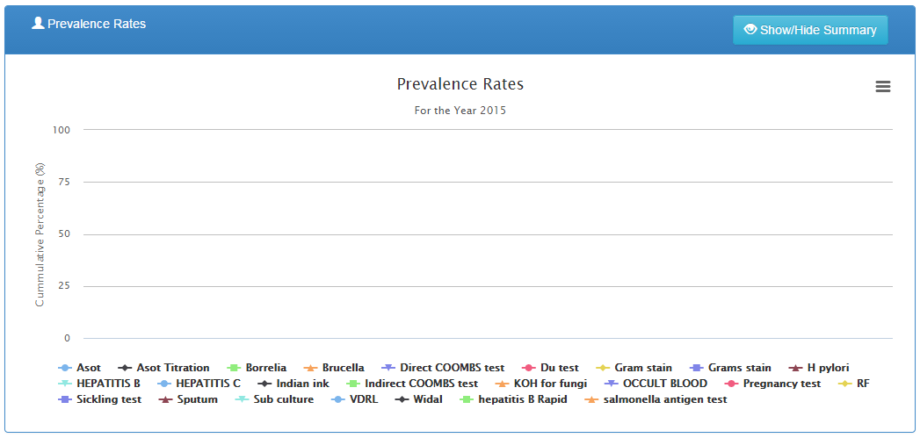

1. Set a date range to view infection graph and prevalence rates. You can also specify the lab section.



1. Click the  button to load the report with the filters you defined e.g.

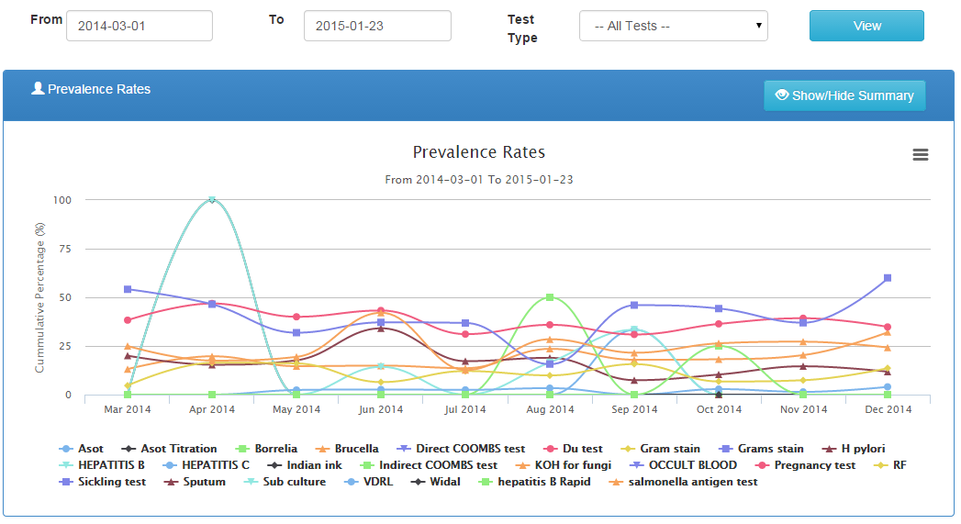

1. You can view a numeric summary of the prevalence rates by clicking the  button to reveal the numeric data.

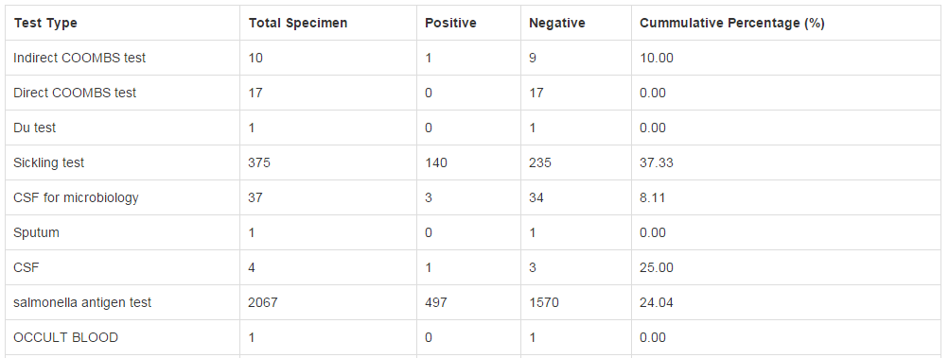

1. You can click on a test on the legend section to hide its graph



### 4.2.2 Counts reports

Generates a report for a particular time period of the number of tests and specimens both grouped and ungrouped.

1. Click the  sub-menu to launch the counts reports options

#### 4.2.2.1 Test counts (Ungrouped)

Shows for each test, the number of complete vs pending tests overtime.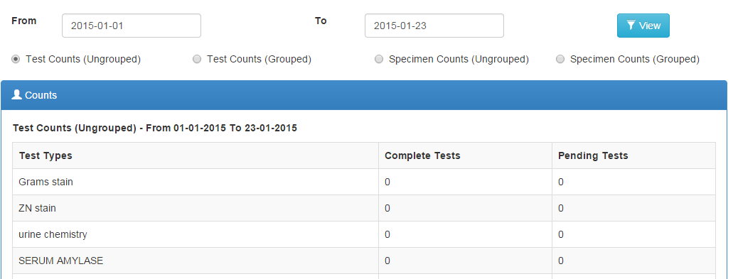

The report can be filtered by specifying date ranges then clicking the  button to load the report with the applied filters.

#### 4.2.2.2 Test counts (Grouped)

This is a report that groups tests according to various parameters such as lab section, gender, age ranges then counts the numbers for each while showing the total tests run.

Click the checkbox then  to load the report

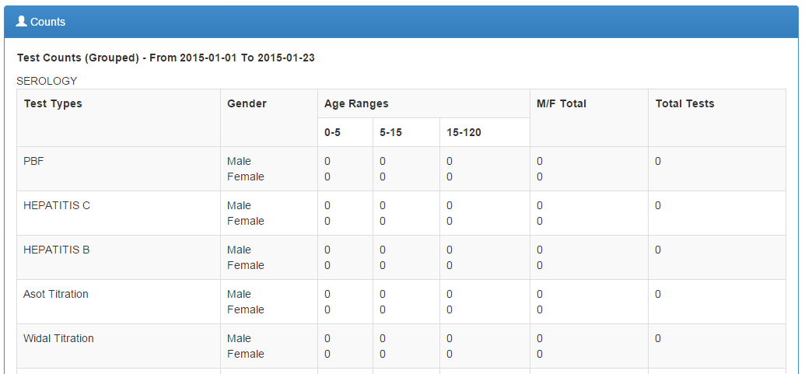

#### 4.2.2.3 Specimen counts (Ungrpuped)

It is a count for accepted vs rejected specimen

Click the then  to load the report

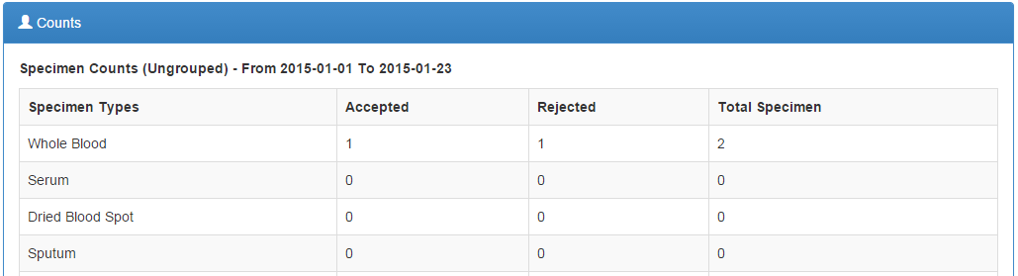

#### 4.2.2.4 Specimen counts (Grouped)

Click the checkbox then  to load the report

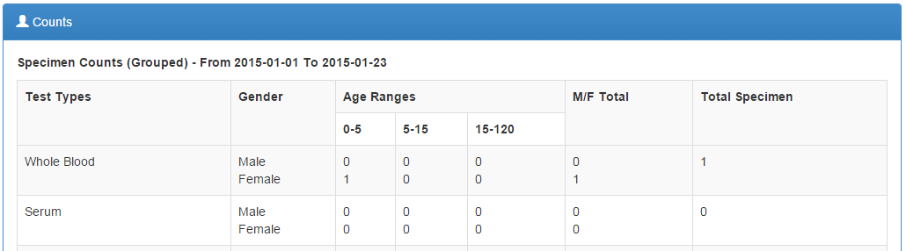

### 4.2.3 Turnaround time report

Allows you to see actual turnaround times between test order and completion for all or specific tests.

1. Click the  sub-menu to load the report
2. Set a date range then click the  button to filter the report. The default is data for the current year.

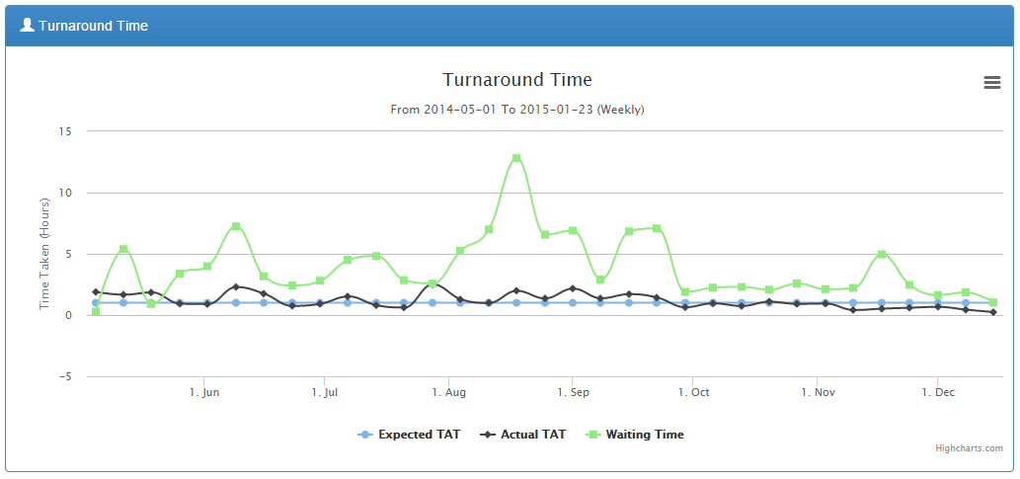

1. You can choose to run a log for one lab section or for one type of test. The default settings are test records, all sections, and all tests.
2. The report loads with Export controls which can be accessed by clicking the icon where the chart can be exported to PDF document or as an image.

### 4.2.4 Infection report

Allows you to generate reports of infections by patient age and gender.

1. Click  sub-menu to load the report. By default, it loads data counts for the current year.

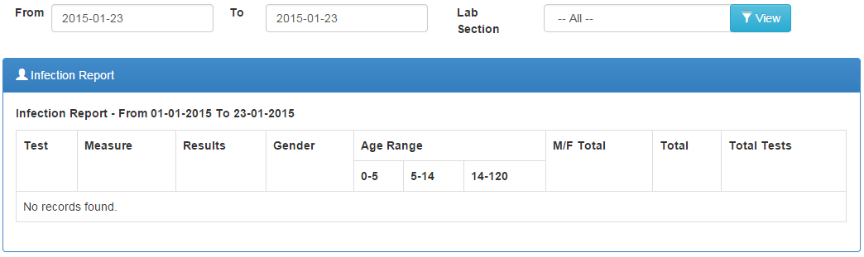

1. Set a date range or select one Lab Section, or all sections to see all test results after clicking the  button.

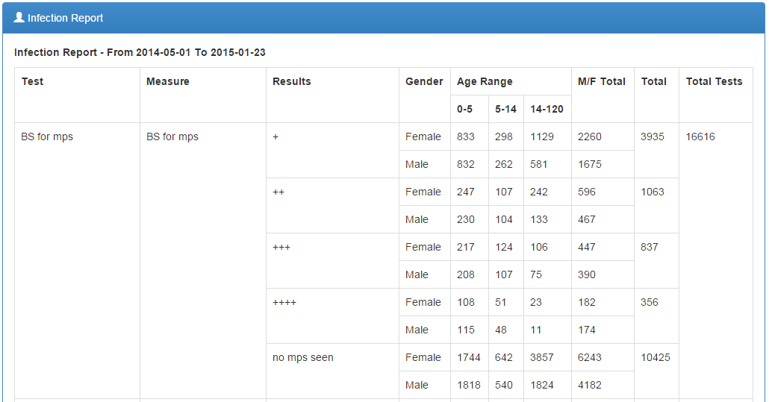

# **5.0 User Account**

Allows users signed into the system to update their accounts such as passwords for security reasons, adding profile pictures and so forth.

Click the  sub-menu to open the user details page.

## **5.1 Editing your user profile**

1. Click the  tab on the tabbed bar
2. Make modifications to the details using the form provided

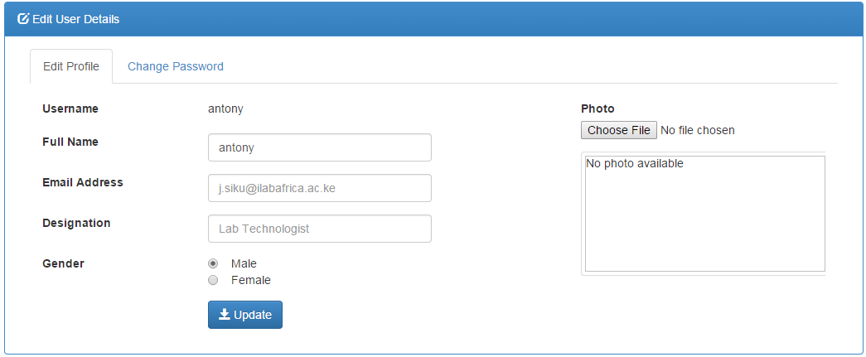

1. Click the  button to save the changes

## **5.2 Changing your password**

1. Click the , change password tab.
2. Make necessary modifications to the data. Remember the new password MUST match retyped password.

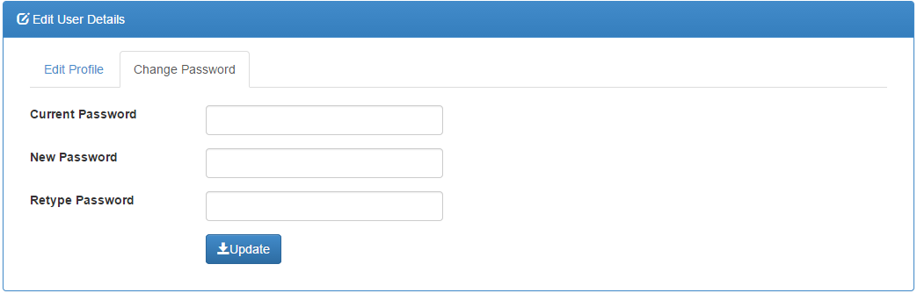

1. Click the  button to save the changes

## **5.3 Signing out of the BLIS**

1. Go to the top right corner of the top bar where your username is indicated e.g. Antony



1. Click on the username to open a menu with and  links.
2. Click the **Logout** link to be sign out. You should be redirected to the login page of BLIS.

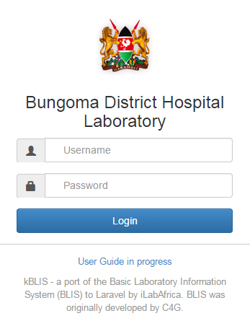

# **Glossary**

Admin – Designation for a user that has control over lab configuration settings.

Reports – Pages that collect metrics for various types of data. The scope of these reports varies from individual patients to entire groups of laboratories.

Aggregate – Type of report that collects data over a period of time and presents it to the user.

Results - The recorded outcome of tests performed on specimens.

Specimen – An entry representing a physical specimen or reading taken from a patient.

Specimen Type – Classification for different types of specimens.

Grouped Reports – Reports that cover multiple types of information.

Technologist – A designation for a user who is tasked with entering data into BLIS.

Test – An entry representing a test or reading taken from a specimen.

Test Type – Classification for different types of tests.

Turnaround Time – A measurement of the time it takes to receive a result, once a specimen is collected.

Patient – Entry for a patient whose specimens, tests are performed on.

User – Any person or entity that logs into the BLIS program.

Prevalence Rate – The percentage rate of occurrence of a particular result of tests.

Verify – An action performed on test entries that validates the results for further use.

Registration – The act of entering a patient into the BLIS program. Creates a unique patient entry that can be associate d with specimens and tests.